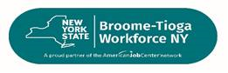



**Job Search Workshop and Job Fair**

**Tuesday May 6th, 2025**

**1pm-3pm**

**Workshop will be from 1pm-2pm**

**Job Fair: From 2pm-3pm**

**To register you can call 607-778-2136 or use the Link** [**https://forms.office.com/g/YQVsTit0yL**](https://gcc02.safelinks.protection.outlook.com/?url=https%3A%2F%2Fforms.office.com%2Fg%2FYQVsTit0yL&data=05%7C02%7Cpreston.hertzog%40broomecountyny.gov%7C8c6ec416d47348ab05ae08dd872a3815%7C754a5ad4d1ae4a0eb53a464544a20db2%7C1%7C0%7C638815337621089755%7CUnknown%7CTWFpbGZsb3d8eyJFbXB0eU1hcGkiOnRydWUsIlYiOiIwLjAuMDAwMCIsIlAiOiJXaW4zMiIsIkFOIjoiTWFpbCIsIldUIjoyfQ%3D%3D%7C0%7C%7C%7C&sdata=WX9DJJZPjgdLXvEHDhpp98Or5KfteHjdO1CnggyfIEU%3D&reserved=0) **or**

**QR Code:**

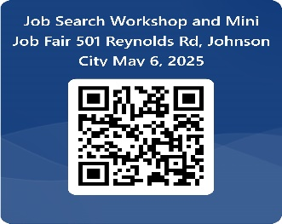

**Hiring For:**

**PCA/HHA/CNA and Caregivers**

**Personnel:**

**Multiple Positions**

**Located at 501 Reynolds Road Johnson City NY 13790**