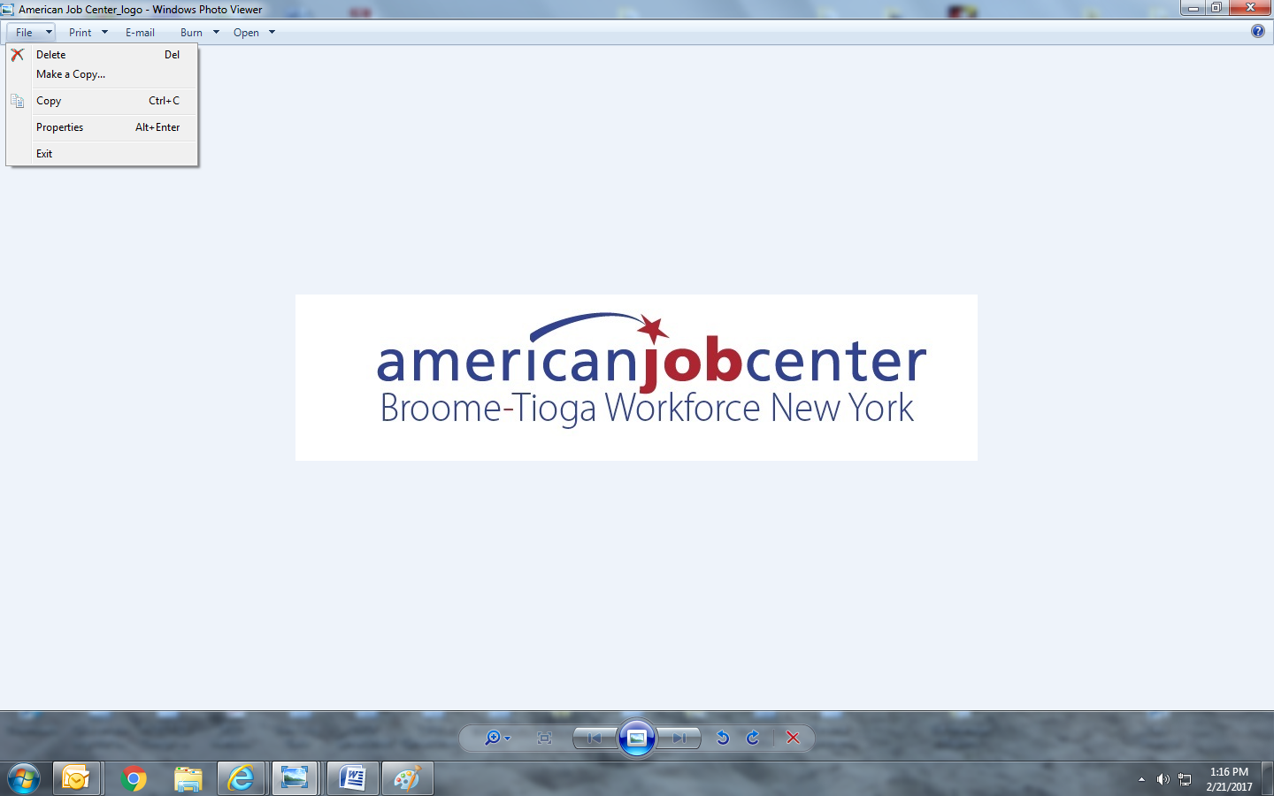

Broome Tioga Workforce NY WDB Meeting

March 21st, 2025

12 noon

**WDB Members:**

In-person attendance: Amy Foster, Michael Atchie, Len Basso (Vice Chair), Tom Crowley, Allyn W. Jones, Jonathan Layish, Justin Marchuska, Paula Perna, Karen Shelp (Chair), Wendy Getchell, Shawn Yetter, Frank Stento, Vikki Kaufman and Andrew Tunison.

Zoomed or called in: No Zoom available.

Excused: Rebecca Stone, Shawn Atkinson, Danielle Britton, Brian Scanlon, Brittany Woodburn, Mary Hill, Barrett Grant, Jesus Clark, Robert Messler, Chris Powers.

**Staff and guests:**

In person attendance: Robert Murphy (RCM – Host, BTWF-Broome), Dave Goguen (BTWF), Holly Tracy (Broome CCE), Kevin Harlost (BTWF-Broome) Lisa Weston-Bialy (Tioga CCE), Erin Evans (Tioga CCE), Jacopo Moroni (BTWF), Megan Slilaty (BTWF)

Zoomed or called in: No Zoom available.

Handouts: Agenda, LWDB Minutes from December 2024, Exec. Committee Meeting minutes from March 14th 2025, Broome CCE Career Bound WDB Report PY24 3rd Quarter, Tioga CCE WDB Report PY24 3rd Quarter, Youth Contracts Fiscal Status as of 2/28/2025, Previous Proposed Budget Adjustment for Tioga County, Previous Summary of RFP- for Literacy Volunteers of Broome Tioga Counties, New Budget Adjustment DW to Adult Transfer, ITA Policy Change, Labor Market Profile, and NYATEP 2025 flyer.

1. Karen Shelp as Chair called the meeting to order at 12:00 pm.
2. Introduction of Members and Guests

RCM welcomed everyone to the meeting.

1. Review and approve previous WDB meeting minutes.

Minutes for the meeting held on December 13th, 2024, were reviewed. Motion to accept December 13th WDB meeting minutes. Len Basso 1st, Frank Stento 2nd. All in favor.

1. **Old Business**- Bob discussed the matters from the December 2024 meeting that required a vote.
2. Transfer of funds to Tioga County- to amend vote from the June 2024 LWDB Meeting.

* Motion to approve the transfer of funds to Tioga County. 1st Len Basso, 2nd Karen Shelp. All in Favor

1. Approval of RFP’s- Literacy Volunteers of Broome- Tioga Counties Inc

* Motion to approve the RFP for Literacy Volunteers. 1st Paula Perna, 2nd Michael Atchie. All in Favor.

1. Approval of a successful bidder in response to the RFP. Approval from the December 2024 meeting:

* Motion to approve the successful bidder in response to the RFP. 1st Frank Stento, Len Basso, All in Favor.

1. **New Business**
2. Board Member changes: Introduced two new Board members, Wendy Getchell from Amatek and Amy Foster from Tioga Opportunities.
3. Youth Program fiscal status @ 2/28/25.

* Kevin Harlost referred to the handout listing Broome CCE and Tioga CCE’s claims for the period ending 2/28/2025.
* Tioga CCE claimed $311,260.46 for 32 months (July 2022 – February 2025) in PY22/24. The last claim received was for February 2025. The claims were 3% underclaimed (last quarter underclaimed by 9%).
* Youth work experience was $46,937.24 and was 27% underclaimed (last quarter underclaimed 28%). Tioga CCE has been keeping up with the minimum 20% requirement for Youth Work Experience expenditure per agreement.
* Broome CCE claimed $383,574.87 for 32 months (July 2022 –February 2025) in PY22/24. The last claim received was from January 2025. This was 4% under budget. (Previous Quarter was 5%.
* Youth work experience at $53,219.13 was 33% under-claimed (Last quarter remained the same at 33% under-claimed).

1. Youth Program status:

Broome CCE- (Report Reviewed)

* Holly Tracy informed the Board about Broome CCE’s status for the 3rd quarter of PY24.
* Broome CCE had 43 enrolled in their youth programs and 8 Youth joining March class.
* 21 Sentry Alarms, Dave & Busters, Walmart (2), Chipotle, B-T BOCES, Cracker Barrel, Taco Bell, BC Transit, Vapor King, Dick’s Warehouse, Tioga County DSS, Guthrie, Willow Run, Endicott Thrift, McDonald’s, Achieve, Panera, Lalor Dental, Dominos, and Pizza on the Plaza.

Vocational Trainings

(PY24) 10 youths and an additional 5 youths in progress for the following:

* (1) (DCMO BOCES) LPN
* (3) (BT BOCES) for LPN
* (1) B-T BOCES for Welding

Completed:

* (2) SUNY Broome Lineman program
* B-T BOCES for phlebotomy
* Sage Truck Driving School (CDL A)
* B-T BOCES Building 101

Upcoming:

(2) B-T BOCES for Phlebotomy beginning in March

Tioga CCE –(Report Reviewed)

* Lisa Weston-Bialy informed the Board about Tioga CCE’s status for the 3rd quarter of PY24.
* 44 youths were enrolled for PY24.
* 43 participants were employed at the following locations: Originals, SUNY Broome, Dollar General, Longview, Burger King, Dynamic Cleaning, Parkview, Burger King, Mirabito, Wegmans, OBD, Wendy’s, Stateline, Guthrie, Elderwood, Cortland Park, Best Buy, River Rock, Banana Curve, Nurse Connections, Dunkin, Lowes, Waverly School District, Hometown Bookkeeping, Fairview, AutoZone, Wagner Lumber, OPWDD, Whitney Point Diner, California Grill.
* 45 youth completed the NEW Youth Orientation and Objective setting

Enrolled in Training:

* 2 Google Certificates, 1 Phlebotomy, 2 Driving lessons for employment purposes (Corrections and automotive), 3 Cosmetology, 1 Security Guard, 4 5-hour Pre-Licensing class, 1 OSHA 10
* 8 enrolled in - Post-secondary Ed
* 6 Job Corp: 2 Glemont. 4 Oneonta: (Automotive, CNA, Security, Culinary)
* 3 Obtained Drivers Licenses
* Work Experience: Tioga County Career Center, Refabulous Furnishings, Thunderbird Atlatl, Spencer Van Etten High School and Raymond Hadley
* 1 OJT: Thunderbird Atlatl

1. Approval to increase the Individual Training Assistance (ITA) limit from

$3,000 to $5,000 and the lifetime of the participant from $6,000 to $10,000.

* Robert Murphy discussed the current ITA policy and the adjustment to the funds for the participants.

Motion to approve the ITA policy limit from $3,000 to $5,000 and the lifetime of the participant from $6,000 to $10,000. 1st Frank Stento. 2nd Len Basso. All in Favor.

1. Broome Tioga Workforce- Transfer of $200,000 from PY24 DW to PY24 Adult.

* Kevin Harlost discussed the transfer of $200,000 from the PY24 DW to PY24 Adult. This is to accommodate the higher usage of Adult funds than DW at this time.

Motion to approve transfer of $200,000 from PY24 DW to PY24 Adult. 1st Paula Perna, 2nd Michael Atchie. All in Favor.

1. Grant Discussion:

* Bob discussed the WIOA Re-authorization funding and our spending on training and wrap-around services. The NYATEP Form handed out at the beginning of the meeting was reviewed.
* Bob discussed the Sage Trucking Closure in Binghamton and the next steps Broome Tioga Workforce will be taking to maintain training for our participants.

1. Labor Market Report – Christian Harris

* Christian Harris from NYSDOL reported on the latest statistics from the Labor Dept.
* Binghamton MSA’s unemployment rate, 4.8%
* Total Job counts positive but narrowing. Opportunities are high.
* Tariffs were discussed, and their effect on the economy.

1. Any other matters –

* All County Job fair on April 2nd.

1. Future WDB Meeting in 2024 –

June 20th, 2025, 12:00 PM

September 19th, 2025, 12:00 PM

December 12th, 2025, 12:00 PM

1. There being no further matters, motion to adjourn the meeting.

Frank Stento 1st, Andrew Tunison 2nd. All in favor.

The meeting adjourned at 12.57 PM.