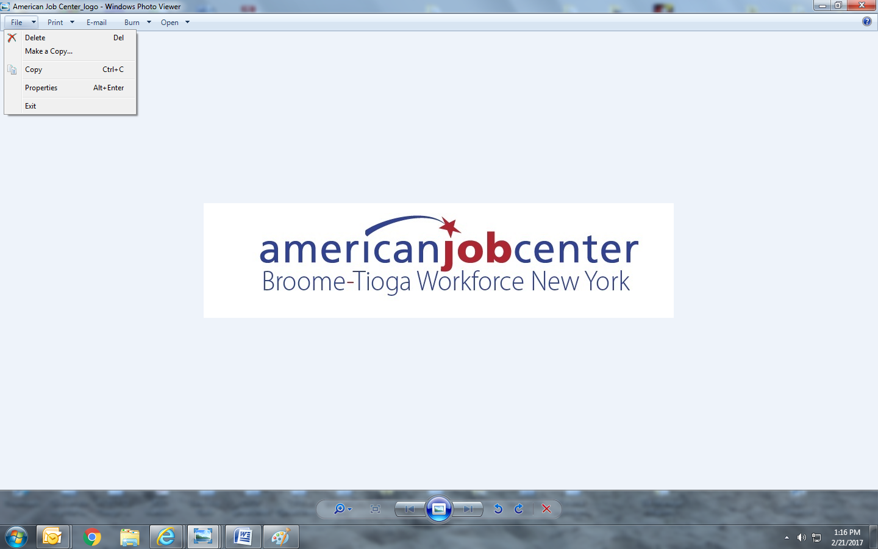

Broome Tioga Workforce NY WDB Meeting

December 13th, 2024

12 noon

**WDB Members:**

In-person attendance: Len Basso (Vice Chair), Allyn W. Jones, Jonathan Layish, Justin Marchuska, Karen Shelp (Chair), Rebecca Stone, Shawn Yetter, Chris Powers, Michael Atchie, Frank Stento, Vikki Kaufman and Andrew Tunison.

Zoomed or called in: Paula Perna.

Excused: Shawn Atkinson, Maureen Abbott, Robert Messler, Teresa Rennia, Danielle Britton.

Tom Crowley, Brian Scanlon, Brittany Woodburn, Mary Hill, Barrett Grant, Jesus Clark.

**Staff and guests:**

In person attendance: Robert Murphy (RCM – Host, BTWF-Broome), Dave Goguen (BTWF), Holly Tracy (Broome CCE), Kevin Harlost (BTWF-Broome) Lisa Weston-Bialy (Tioga CCE), Jacopo Moroni (BTWF), Megan Slilaty (BTWF), Brianna Murphy (BTWF- Broome) (Parker- Tioga CCE Guest Speaker)

Zoomed or called in: Jackie Burdick (BTWF – Tioga)

Handouts: Agenda, LWDB Minutes from September 20th, Exec. Committee Meeting minutes from September 20th, 2024, Broome CCE Career Bound WDB Report PY24 2st Quarter, Tioga CCE WDB Report PY24 2st Quarter, Youth Contracts Fiscal Status as of 11/30/2024, Proposed Budget Adjustment for Tioga County, Summary of RFP- for Literacy Volunteers of Broome Tioga Counties, Labor Market Profile, and Unemployment Rank as of 11/30/2024.

1. Karen Shelp as Chair called the meeting to order at 12:20 pm. The Quorum was not met.
2. Introduction of Members and Guests

RCM welcomed everyone to the meeting.

1. Review and approve previous WDB meeting minutes.

Minutes for the meeting held on September 20th, 2024, were reviewed. Motion to accept September 20th,2024 WDB meeting minutes. Len Basso 1st, Rebecca Stone 2nd. All in favor.

1. New Business
2. Board Member changes: None.
3. Youth Program status:

* Broome CCE- (Report Reviewed)
* Holly Tracy handed out CareerBound Flyer for Young Adult Employment Program.
* Holly Tracy informed the Board about Broome CCE’s status for the 2nd quarter of PY24.
* Broome CCE had 26 enrolled in their youth programs and 1 to be enrolled within the next few months.

13 youths were employed (PY24) by Sentry Alarms, Dave & Busters, Walmart (2), Chipotle, B-T BOCES, UHS, Cracker Barrel, Taco Bell, Ideal Bowl, BC Transit, Vapor King, and Dicks Warehouse.

* Vocational Trainings (PY24) 9 youths and an additional 7 youths in progress for the Following:
* 1 (DCMO BOCES) LPN
* 3 (BT BOCES) for LPN
* 1- BT BOCES for Phlebotomy
* 1 Sage Truck Driving School (CDLA)
* 1 BT BOCES Building 101

Completed: (2) Suny Broome Lineman Program

* 1 youth has been enrolled in OJT with local employer Sentry Alarms. Currently in progress to completion.
* Holly discussed their newly hired Educator and shared 2 individual success stories.
* Tioga CCE –
* Lisa Weston-Bialy reported for Tioga CCE.
* Tioga CCE’s reported for the 2nd quarter that 29 youths were enrolled for PY24.
* Lisa introduced Parker; He spoke briefly about his success story. The participant is thriving after getting his GED and is now in college. He will be starting a comedy club in the coming year.

1. Broome Tioga Workforce: Brianna Murphy shared a success story.
2. Youth Program fiscal status @ 11/30/2024:

* Kevin Harlost referred to the handout listing Broome CCE and Tioga CCE’s claims for the period ending 11/30/2024.
* Tioga CCE claimed $264,977.80 for 29 months (July 2022 – November 2024) in PY22/24. The last claim received was for October 2024. The claims were 9% under-claimed (last quarter underclaimed by 8%).
* Youth work experience was $41,954.85 and was 28% under-claimed (last quarter underclaimed 25%). Tioga CCE has been keeping up with the minimum 20% requirement for Youth Work Experience expenditure per agreement.
* Broome CCE claimed $344,456.71 for 29 months (July 2022 –November 2024) in PY22/24. The last claim received was from October 2024 This was 5% under budget. (Previous Quarter was 4%.
* Youth work experience at $48,301.94 was 33% under-claimed (Last quarter was 35% under-claimed).

1. Tioga County Transfer of Funds

* Kevin Harlost discussed that the transfer of funds for Tioga County is to amend the vote held in the June 2024 LWDB Meeting. This transfer will be from Broome Tioga Workforce NY’s (Adult) program to Tioga Counties (Adult) Program.

No motion to approve the transfer of funds – Quorum was not met.

1. Approval of RFP- Adult Literacy Service Program for Office of Employment and Training.

No motion to approve the RFP for Adult Literacy Service Programs- Quorum was not met.

1. Approval of successful bidder:

* Literacy Volunteers of Broome Tioga Counties Inc.

No motion to approve the successful bidder Literacy Volunteers of Broome Tioga Counties Inc. – Quorum was not met.

1. Grant discussion:

* OTDA- Office of Temporary Disability Assistance: New grant with Broome Tioga BOCES, to start Youth Employment Program/ Apprenticeship Programs, this coming year.

1. Youth Council:

* David Goguen spoke about trying to get more into school districts. Broome Tioga Workforce NY is sending staff to the schools for outreach, presentations regarding all our services, and even tabling events.

1. Tioga County-

* Sean Lanning spoke about an Education Workforce Report and demonstrated the Tioga County Work-based map. The GIS Map shows targeted industries such as Manufacturing and healthcare services. The GSI Map helps connect businesses in one place by viewing information about what each one has to offer. Tioga has 73 businesses so far, and these are fully accessible to the public. Students can view internships that are close by/ within their county, so they do not have to travel far.

1. Labor Market Report – Christian Harris

* Christian Harris from NYSDOL reported on the latest statistics from the Labor Dept.
* Binghamton MSA’s unemployment rate still on the low end.
* Total Job counts positive but narrowing. Opportunities are high.
* Inflation has changed from 9% to 3%. Causing issues in the Federal Reserve dropping lending rates.
* Change in leadership nationally, stock market is changing.
* We need more workers to provide more services.

1. Any other matters –

* Bob discussed Broome and Tioga CCE’s hard work and trying to continue to help the community.
* Federal reauthorization of WIOA – with our congressions representatives in both the House and the Senate, there is a big push to change the workforce, requirement of about 50% budget into apprenticeship and training, currently we are at about 20%.

1. Future WDB Meeting in 2024 –

March 21st, 2025, 12:00PM

June 20th, 2025, 12:00PM

September 19th, 2025, 12:00PM

December 12th, 2025, 12:00PM

No motion to vote on future meeting- Quorum not met. Noted to put on calendar.

1. There being no further matters, motion to adjourn the meeting.

Michael Atchie 1st, Karen Shelp 2nd. All in favor.

The meeting adjourned at 1:09 PM.